Artificial Intelligence & Machine Learning

Project Documentation
1. Introduction
1.1 Project Title

Rising Waters: AI-Based Flood Prediction and Early Warning System Using Machine Learning

1.2 Team Members & Their Roles

Team Members | Skill Wallet Team ID’s | Roll Numbers (College: ACET)
Mohana Deepika Kancherla (Team Leader) | SWUID2026226898 | 23MH1A0596
Flora Disowja Sarugolu | SWUID2026212008 | 24P35A0549
Santhi Illa | SWUID2026212021 | 24P35A0550
Mathan Bhavesh Hari Raghava Krishna Munaga | SWUID2026212007 | 24P35A0532

2. Project Overview
2.1 Purpose:
To develop an AI-powered web application that predicts the likelihood of flood events using historical weather and environmental data. The system utilizes machine learning algorithms, including Decision Tree, Random Forest, K-Nearest Neighbours (KNN), and XGBoost, to classify flood risk accurately. It provides:
- Flood Risk Prediction (Low / Medium / High)
- Prediction Confidence Score
- Early Warning Notifications
- Decision Support for Disaster Management Authorities

2.2 Features:
- Weather data input through a user-friendly web interface
- AI-powered flood prediction using XGBoost
- Real-time flood risk classification
- Prediction confidence score
- Historical prediction records
- Interactive dashboard for monitoring flood risks
- Integration with weather datasets
- Cloud deployment support (IBM Cloud)

3. Architecture
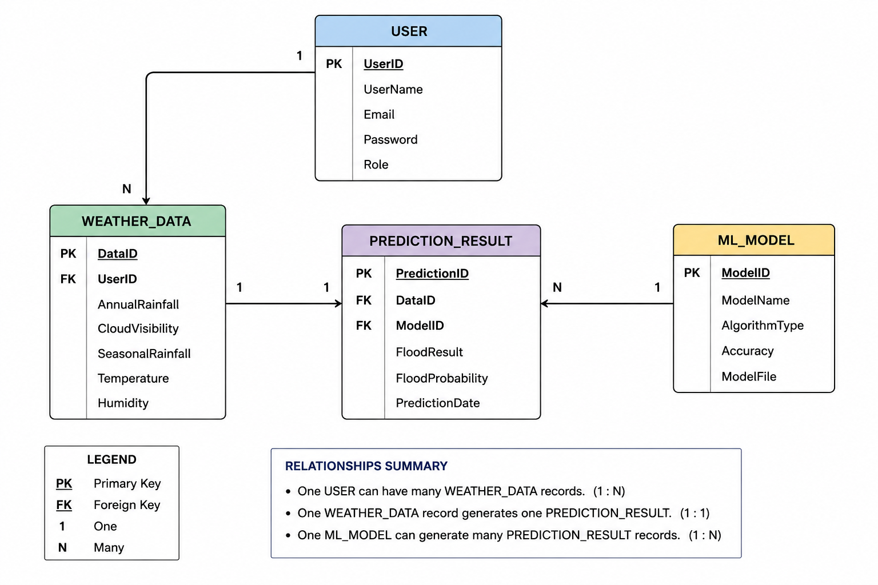

3.1 Backend (Flask)
- Framework: Flask (Python 3.10)
- Machine Learning Models:
- Decision Tree
- Random Forest
- K-Nearest Neighbours (KNN)
- XGBoost (Selected Model)
- Preprocessing
- Missing value handling
- Data normalization
- Feature scaling
- Feature selection
- Modules:
  - app.py – Flask application and API routes
  - predict.py – Prediction logic
  - model.pkl – Trained XGBoost model
  - preprocessor.pkl – Data preprocessing pipeline
  - requirements.txt – Required Python libraries

3.2 Frontend
- Developed using:
  - HTML5
  - CSS3
  - JavaScript
  - Bootstrap
  - Jinja2 Templates

- Pages
- Home Page – Weather parameter input
- Prediction Page – Displays flood prediction and confidence
- Dashboard – Historical predictions and analytics
- About Page – Project information
3.3 Model
Algorithms Evaluated
- Decision Tree
- Random Forest
- K-Nearest Neighbours (KNN)
- XGBoost
Selected Model
- XGBoost Classifier
Libraries
- Scikit-learn
- XGBoost
- Pandas
- NumPy
- Matplotlib
- Seaborn
- Joblib
Evaluation Metrics
- Accuracy
- Precision
- Recall
- F1-Score
- Confusion Matrix
- ROC-AUC Score
Saved Model
- flood_prediction_model.pkl
- preprocessor.pkl
3.4 Dataset
Source
- Historical Flood Prediction Dataset (Kaggle)
- Historical Weather Dataset
- Rainfall Dataset
Dataset Features
- Annual Rainfall
- Seasonal Rainfall
- Cloud Visibility
- Humidity
- Temperature
- River Water Level (if available)
- Flood Occurrence
Preprocessing Techniques
- Missing value imputation
- Duplicate removal
- Data normalization
- Feature scaling
- Train-Test Split
4. Setup Instructions
4.1 Prerequisites:
- Python 3.10+
- Flask
- Scikit-learn
- XGBoost
- Pandas
- NumPy
- Matplotlib
- Joblib

4.2 Installation:

Step-by-step guide to clone, install dependencies, and set up the environment variables.

- Create a virtual environment:
- conda create -n smart-sorting python=3.9
- conda activate smart-sorting
- Install dependencies:
  - pip install -r backend/requirements.txt
- Run the Flask server:
  - python backend/app.py

5. Folder Structure
  - Client: Describe the structure of the HTML, With Internal CSS frontend.
  - Server: Explain the organization of the Flask backend.

6. Running the Application
- Start Flask server: python backend/app.py

7. API Documentation
Route | Method | Description
/ | GET | Load the home page
/predict | POST | Accept weather parameters and return flood prediction
/dashboard | GET | Display historical predictions
/about | GET

8. Authentication
- Authentication is not implemented in the current version.
9. User Interface
9.1 By index.html code
- Starting page & Content Page
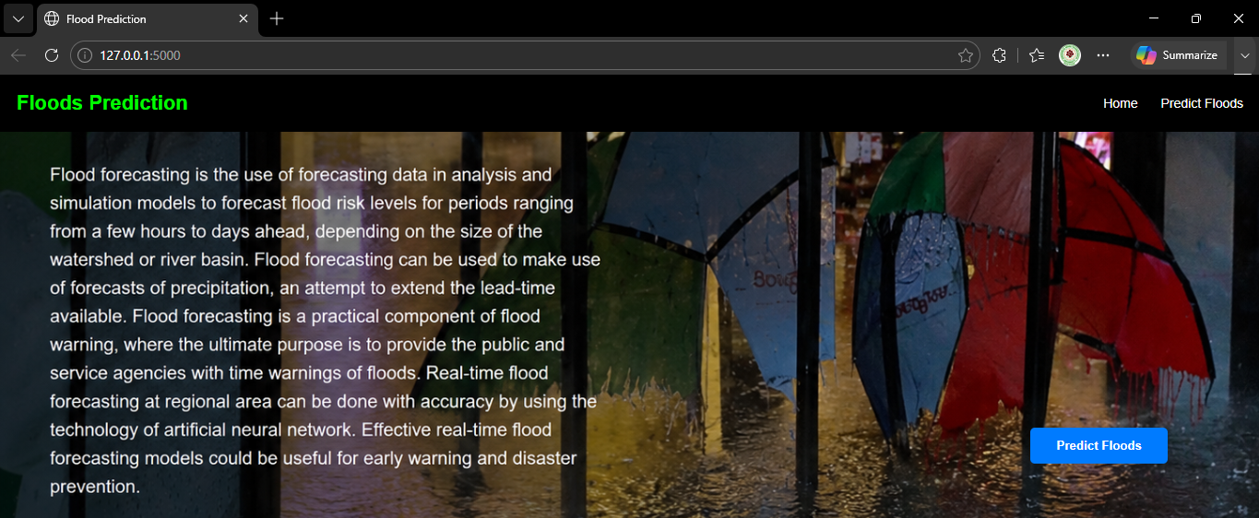
9.2 By result.html
- Prediction table - for safe
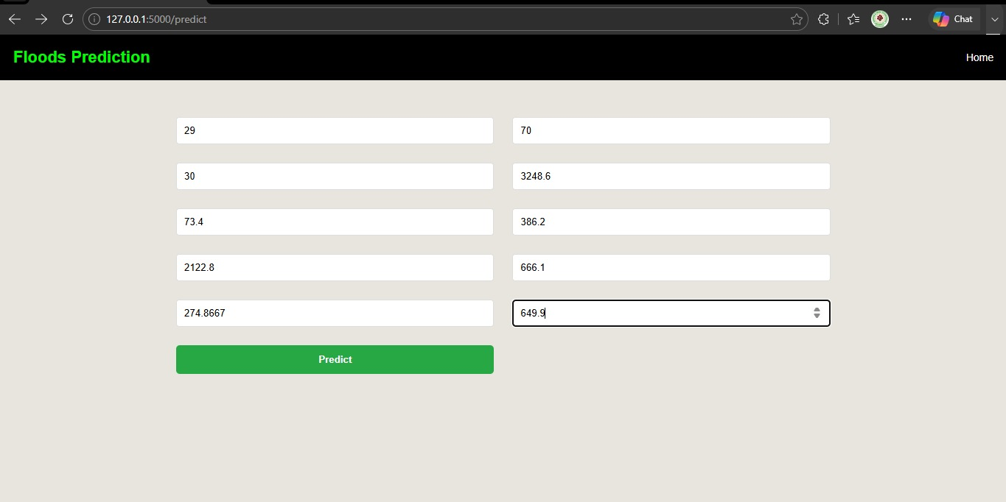

- Output result - for safe
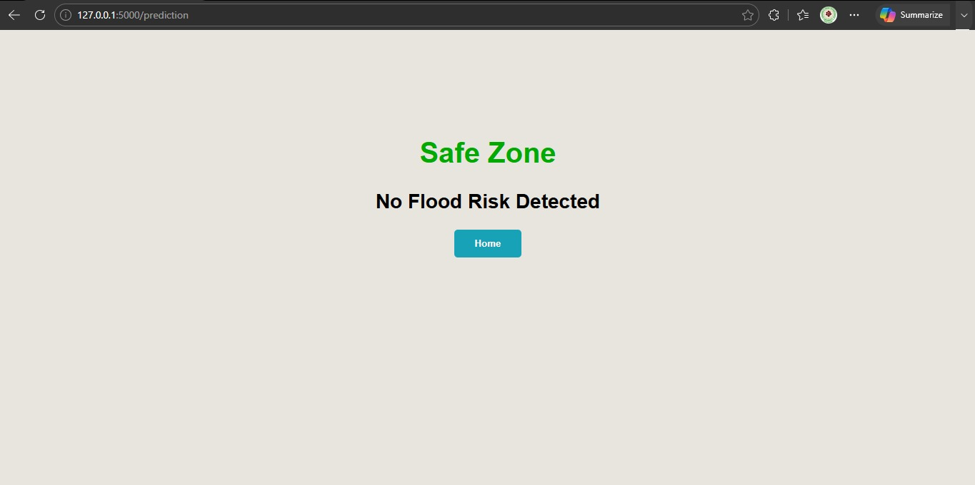

- Prediction table - for unsafe
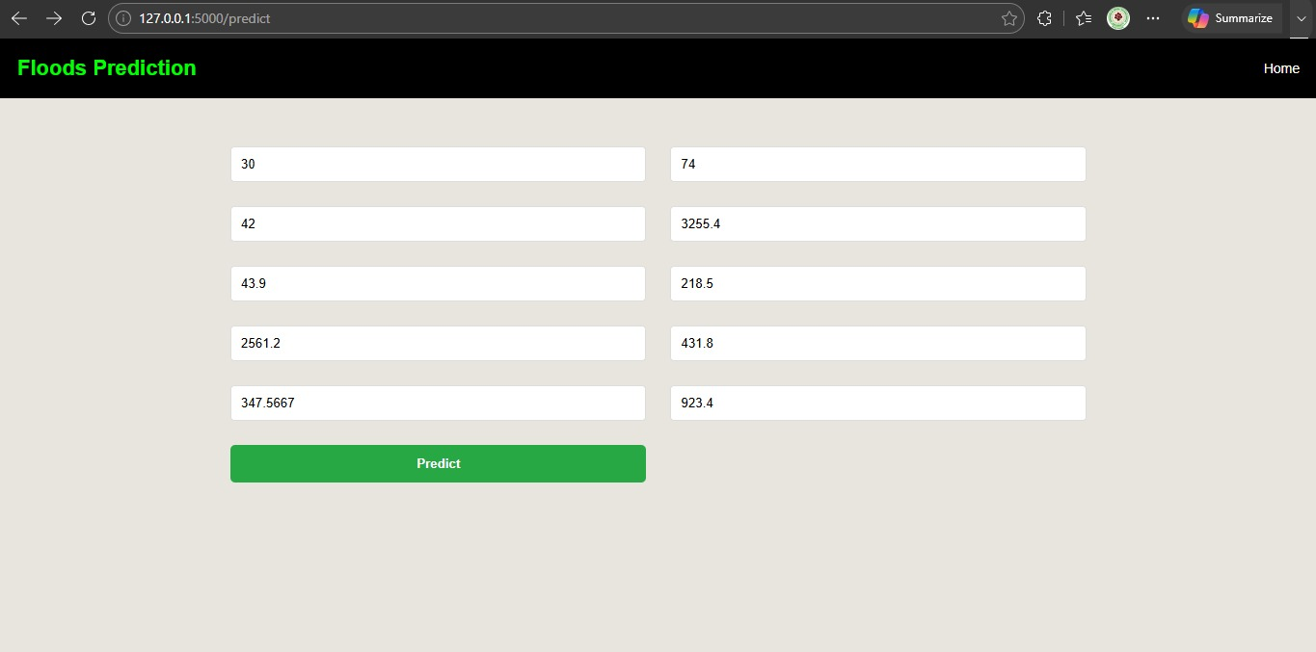

- Output result - for unsafe
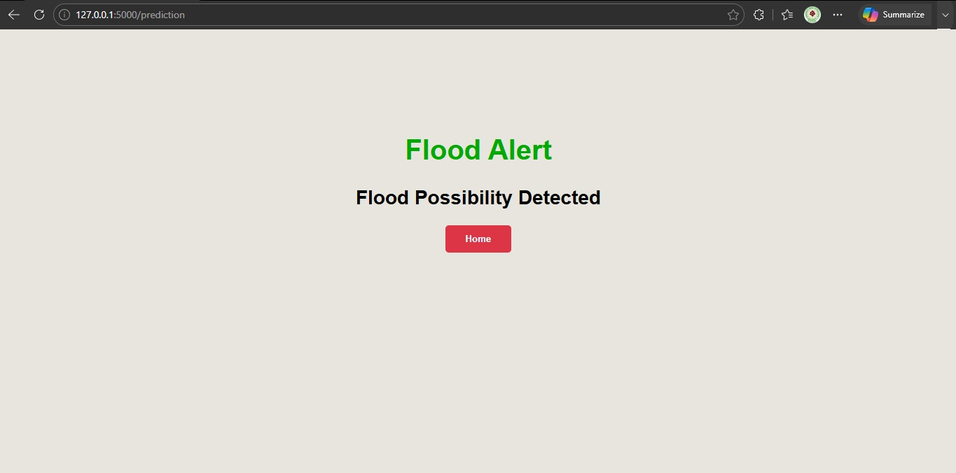

10. Testing
10.1 Data Preparation & Sample Validation
  - Performed by: Mohana Deepika Kancherla
  - Responsibilities:
    - Cleaned and structured dataset from Kaggle
    - Organized class-wise folders for Floods Safe/Unsafe images
    - Manually checked 115 -class image distribution for balance
  - Validation:
    - Verified preprocessed images
    - Helped ensure training/validation split had proper class representation
10.2 Model Testing
  - Performed by: Flora Disowja Sarugolu
  - Responsibilities:
    - Validated model performance on validation data
    - Measured accuracy, confidence score, and class prediction reliability
  - Results:
Model | Training Accuracy | Validation Accuracy
Decision Tree | ~1.0000 (100%) | 1.0000 (100%)
Random Forest | ~1.0000 (100%) | 0.9565 (95.65%)
KNN | Depends on training data | 0.8696 (86.96%)
XGBoost | Depends on training data | 0.8696 (86.96%)
  - Tools & Libraries:
    - Scikit-learn
    - XGBoost
    - Pandas
    - NumPy
    - Matplotlib
    - Seaborn
  - Techniques Used:
    - Confusion Matrix
    - Accuracy, Precision, Recall, and F1-Score
    - Cross-Validation
    - Hyperparameter Tuning
    - Manual Verification Using Historical Flood Test Data
10.3 Flask & UI Integration Testing
  - Performed by: M M Bhavesh H R K
  - Responsibilities:
    - Integrated Flask with HTML templates
    - Ensured routing between /, /predict, and /result
    - Handled static assets (uploaded excel values, result - safe / unsafe)
  - Tools Used:
    - Flask debug server
    - Browser-based testing with real-time uploads
10.4 Web Application Testing
  - Performed by: Santhi Illa
  - Responsibilities:
    - Functional testing of the entire prediction values form excel and checking the result
    - Validated UI pages and error handling
  - Test Cases:
    - Upload valid/invalid result
    - Verify result
    - Test data storage from excel
11. Demo
https://drive.google.com/file/d/1aQnuVJNWRrYiBFr3g0DRYWbMgAsr_m96/view?usp=drive_link

12. Known Issues
- No issues
13. Future Enhancements
  - No need

